1. Visualize the overall distribution of inspection scores using a histogram. [1 point]

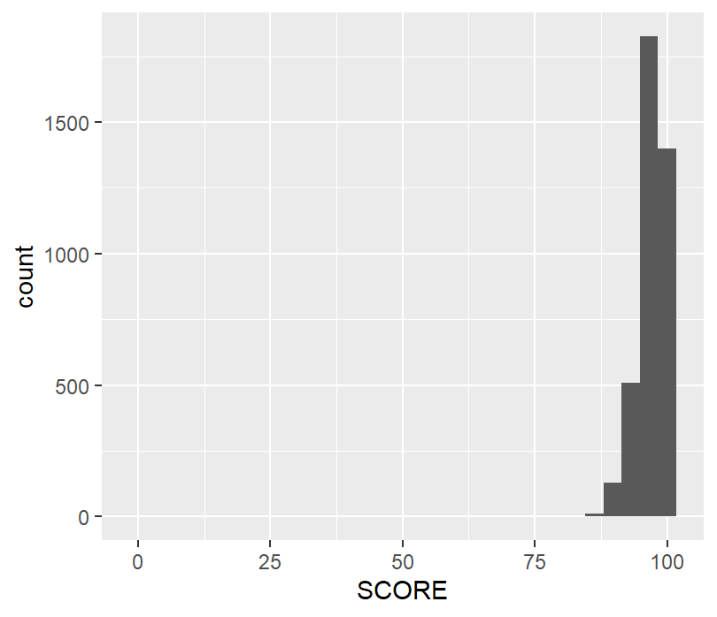

2. Some restaurants have been in business much longer than others. Is there any trend in

terms of how highly older vs. newer restaurants score on their inspections? [0.5 points]

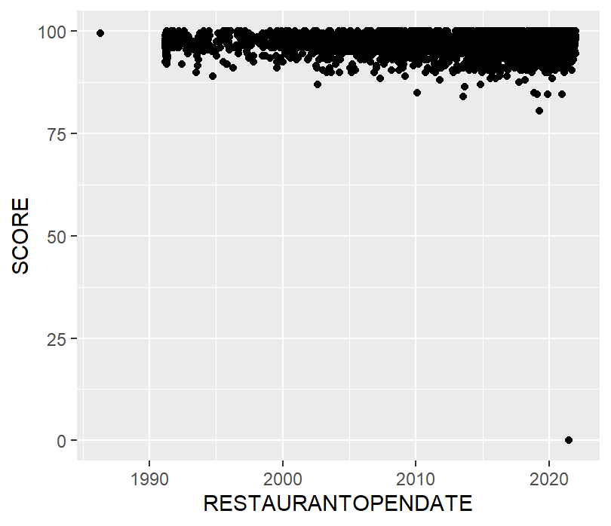

The older restaurants seem to score slightly higher than the newer restaurants.

3. Wake County is the most populous county in North Carolina, and there are many cities

in it. Do the inspection scores vary by city? Note that the city column contains some

differently spelled city names; make sure to clean those up so that there is only one

estimated value per city. The recode function that we used for creating a

weekend/weekday variable in the SFpark exercise will be useful here, and you may also

be interested in the str_to_upper function. [1 point]

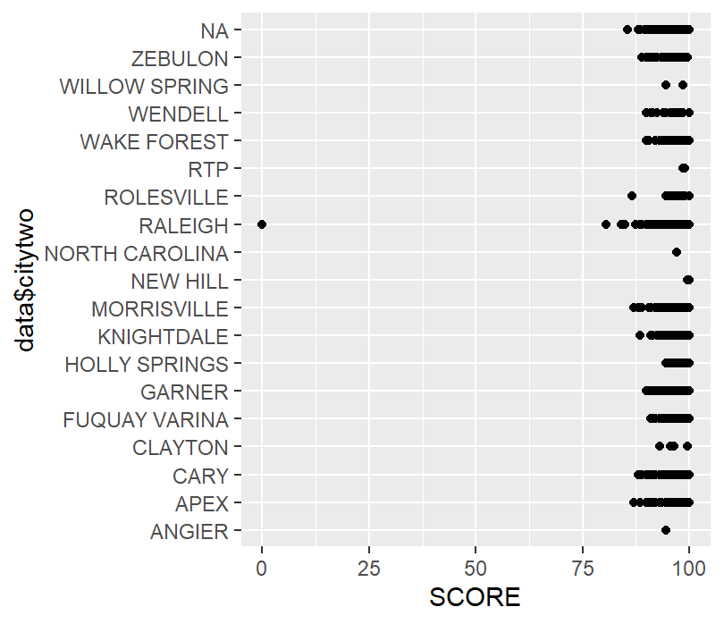 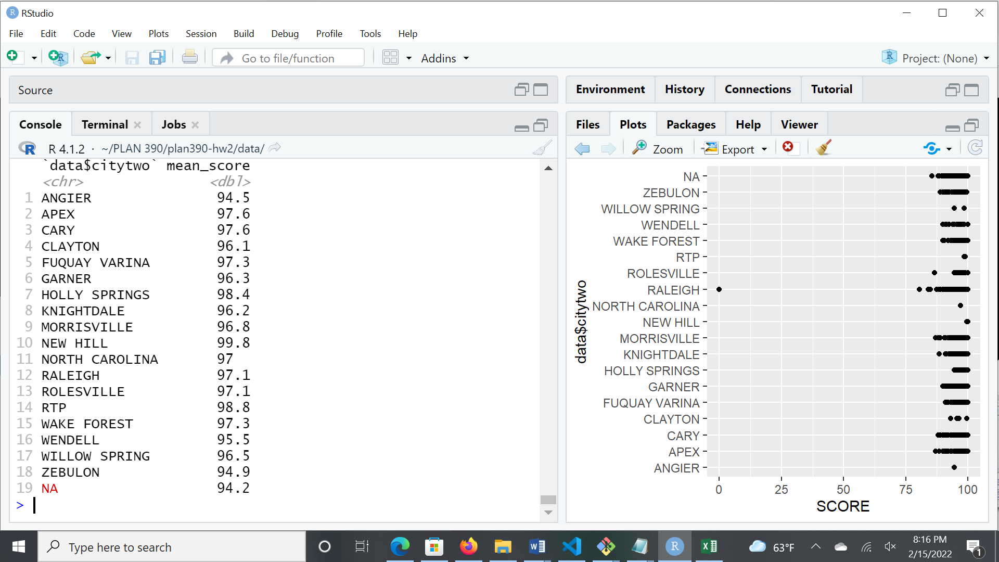

The inspection scores do vary by city.

4. Wake County employs a whole team of inspectors. It is possible that some inspectors

may be more thorough than others. Do inspection scores vary by inspector? [0.5 points]

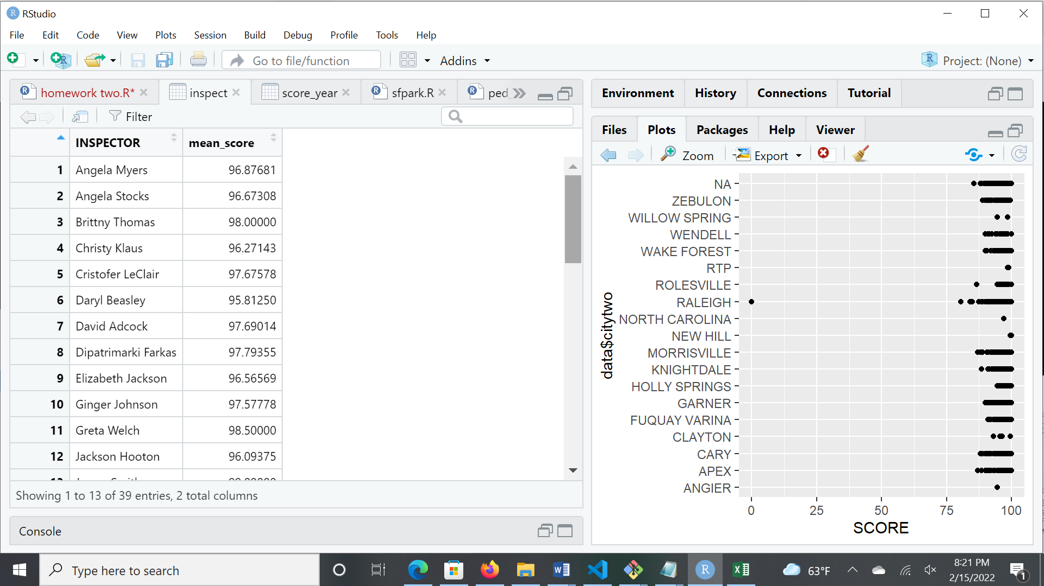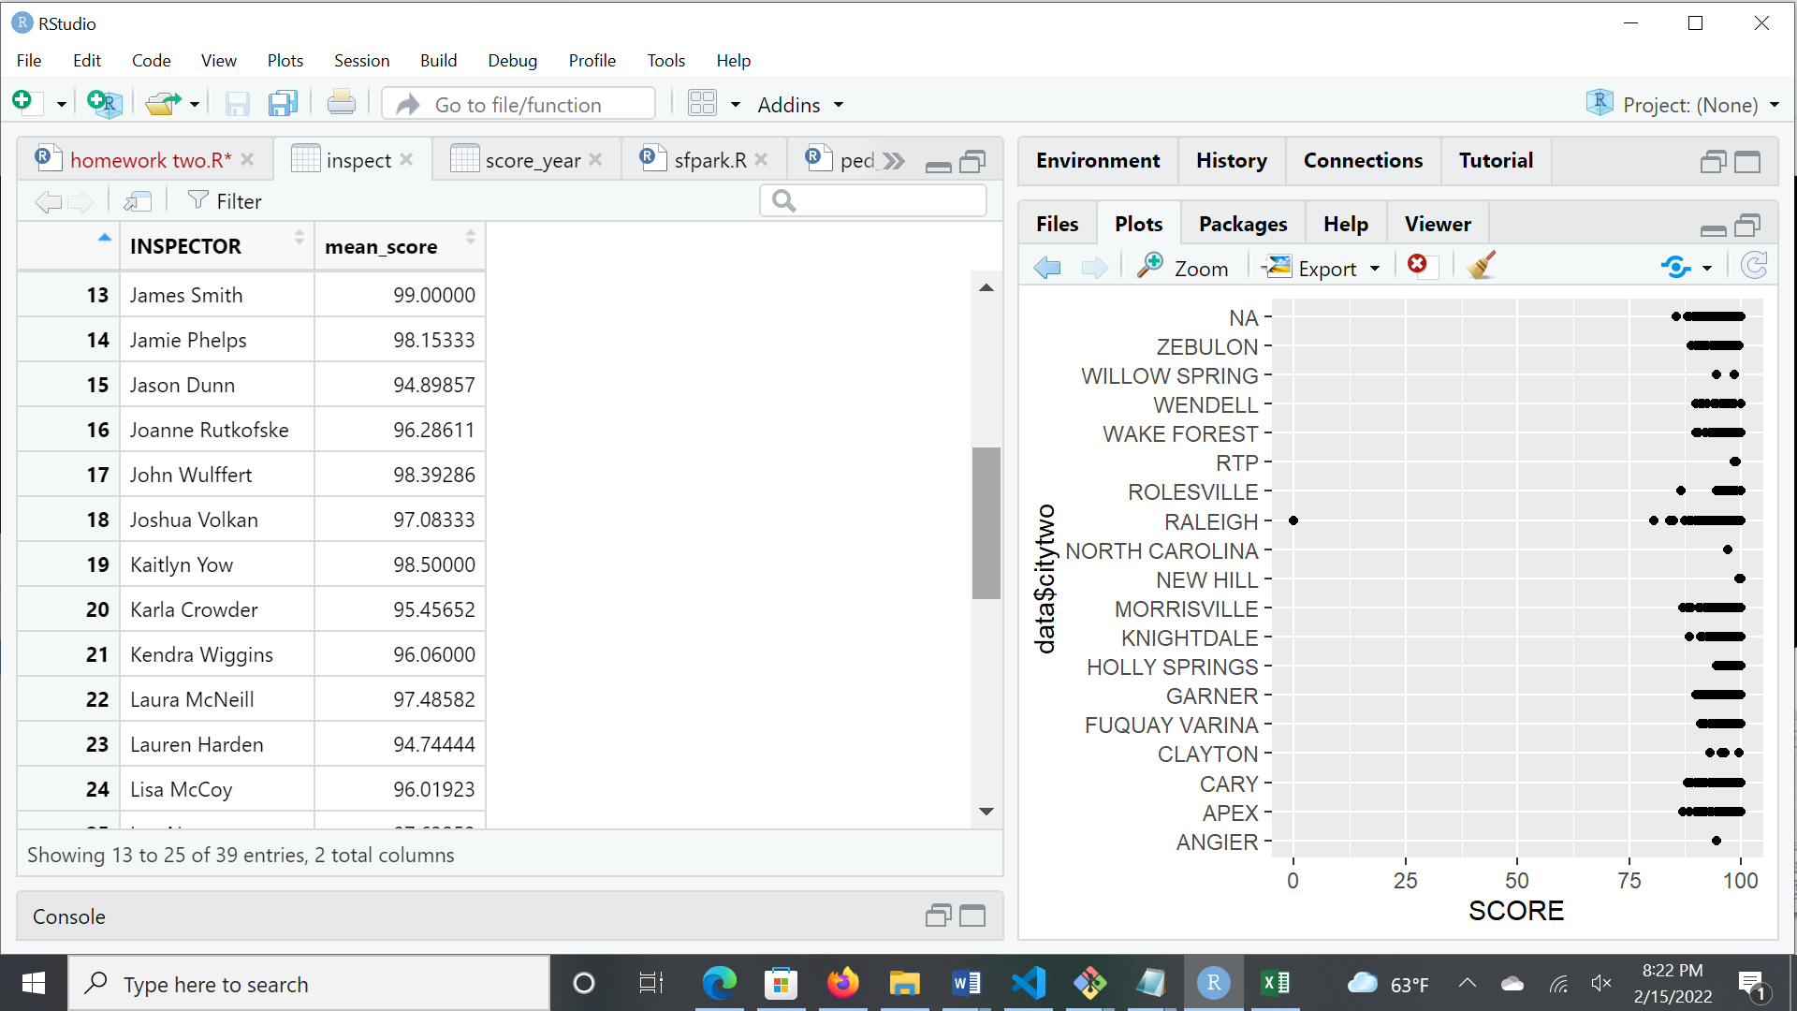 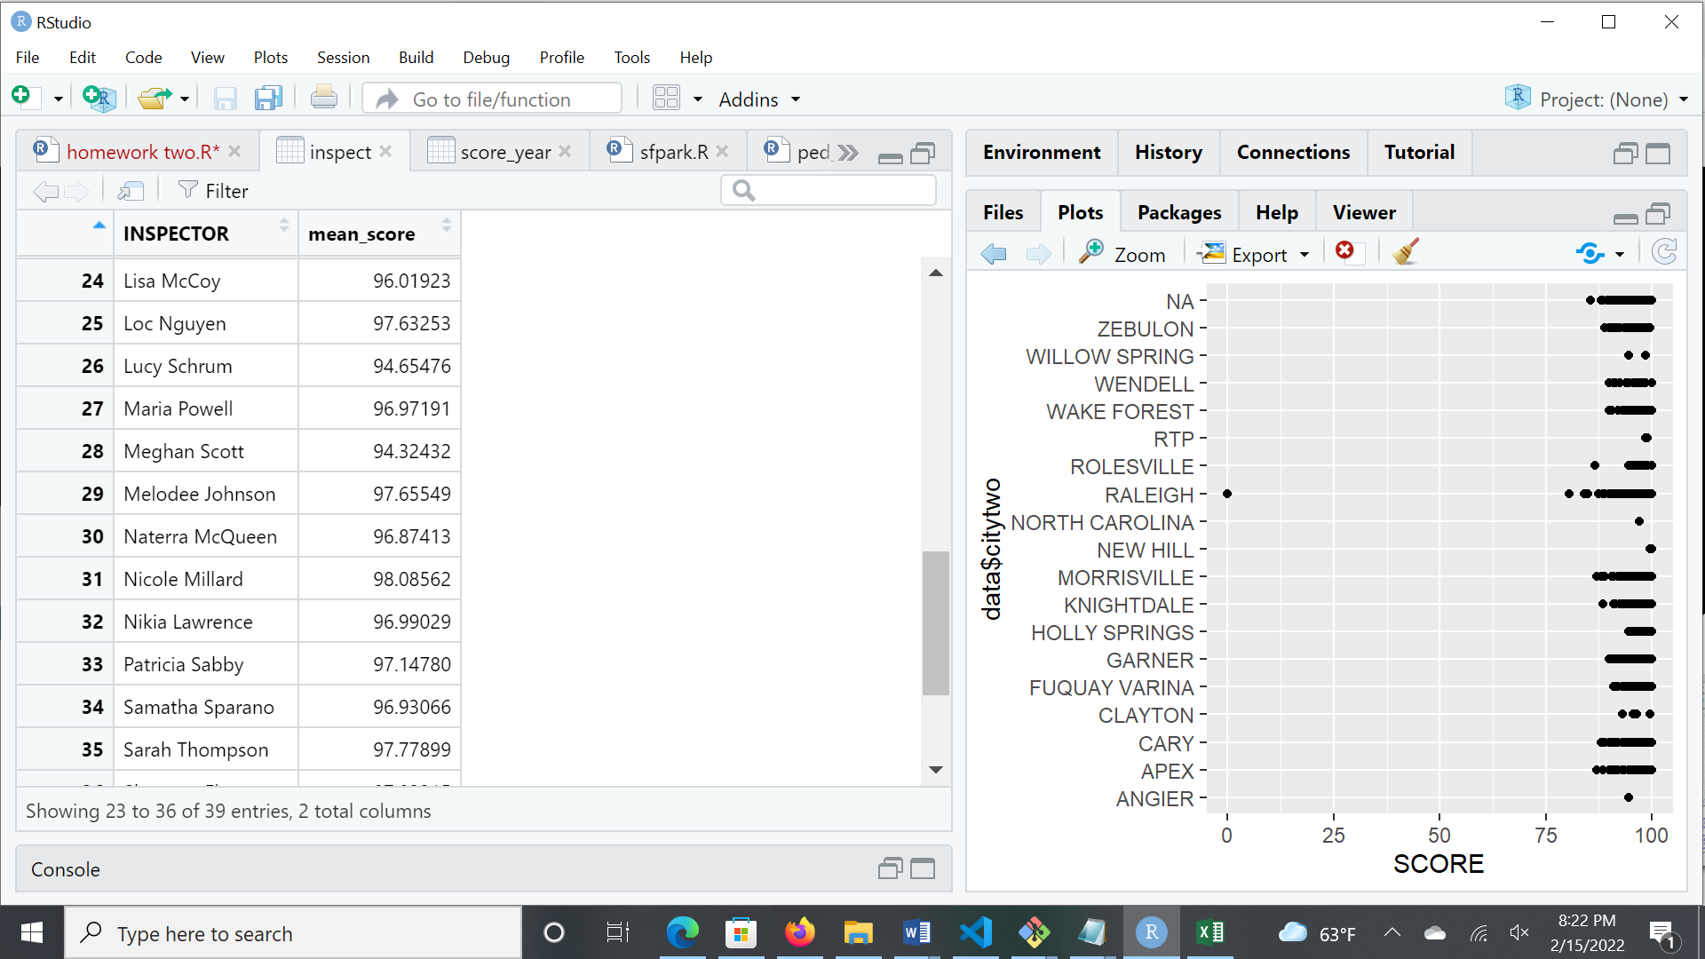

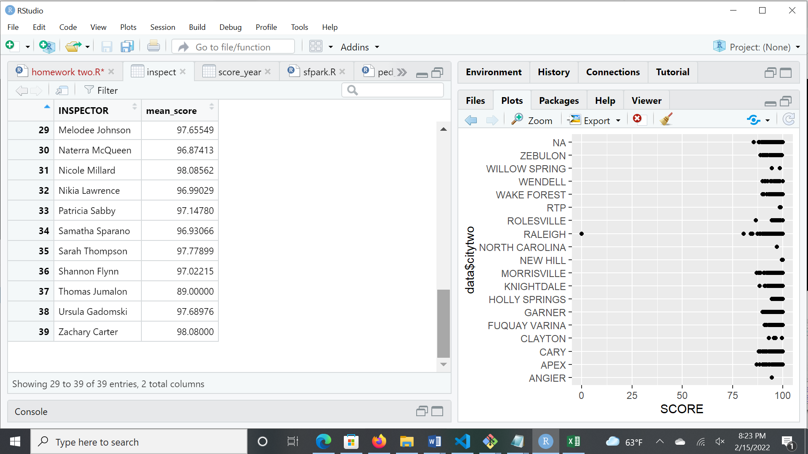

Yes, the inspection scores vary by inspector.

5. It is possible that some extreme results from the previous questions are due to small

sample sizes in a particular city, for a particular inspector, or in a particular time period.

Look at the sample sizes in each of your groups. Do you think this is an explanation for

the results you came to above? [0.5 point]

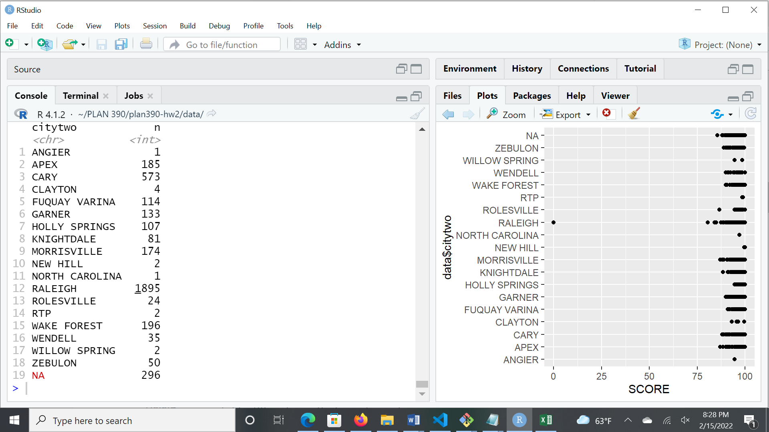 Sample size for particular city.

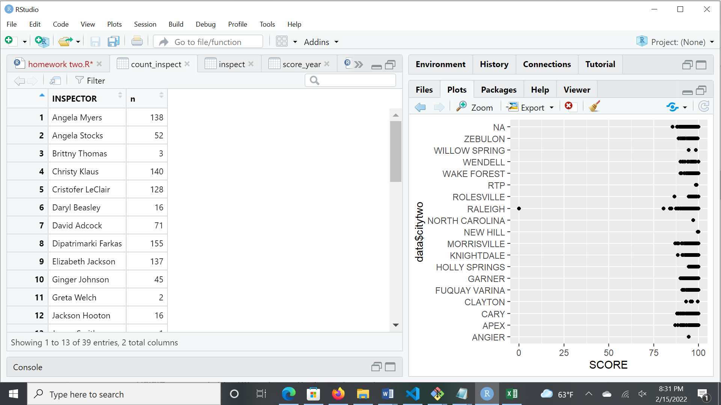 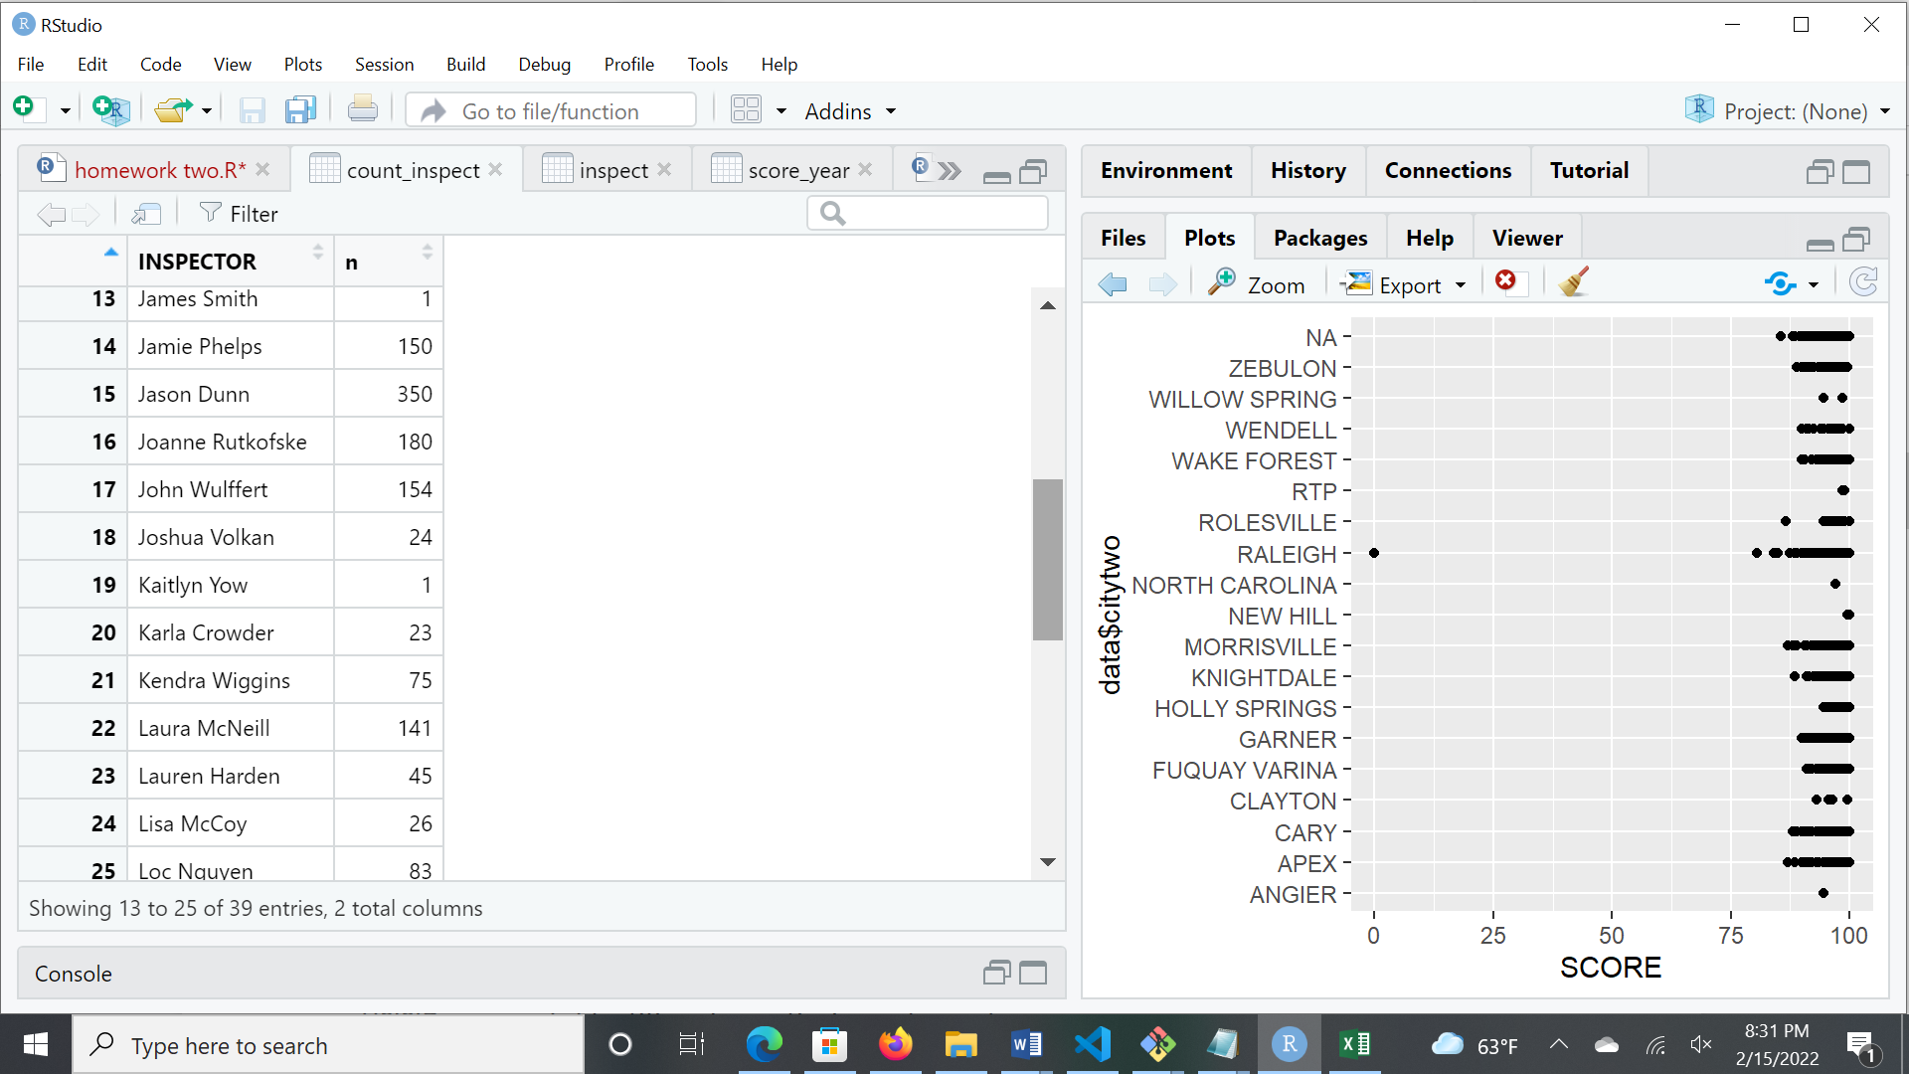 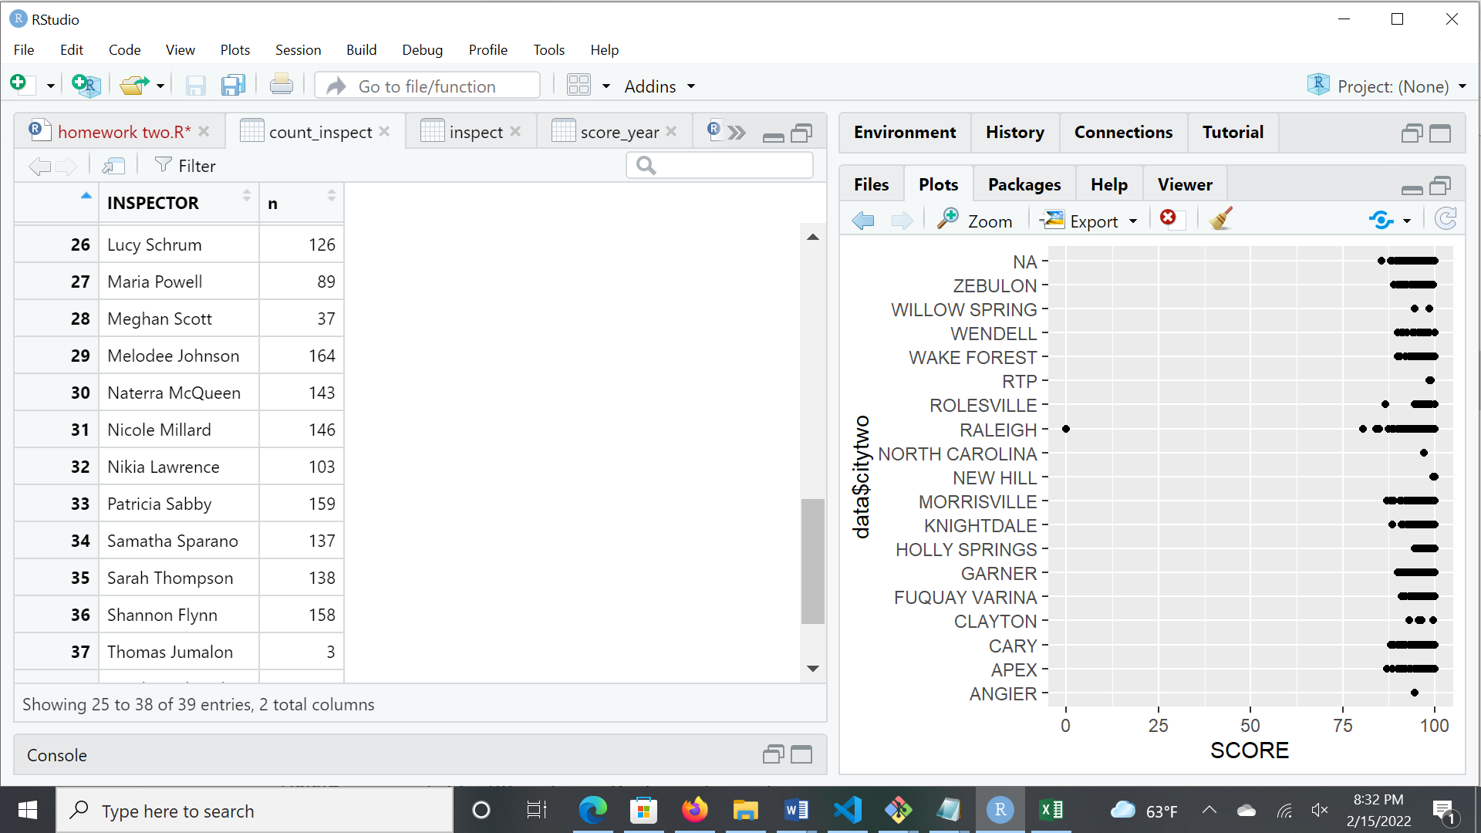 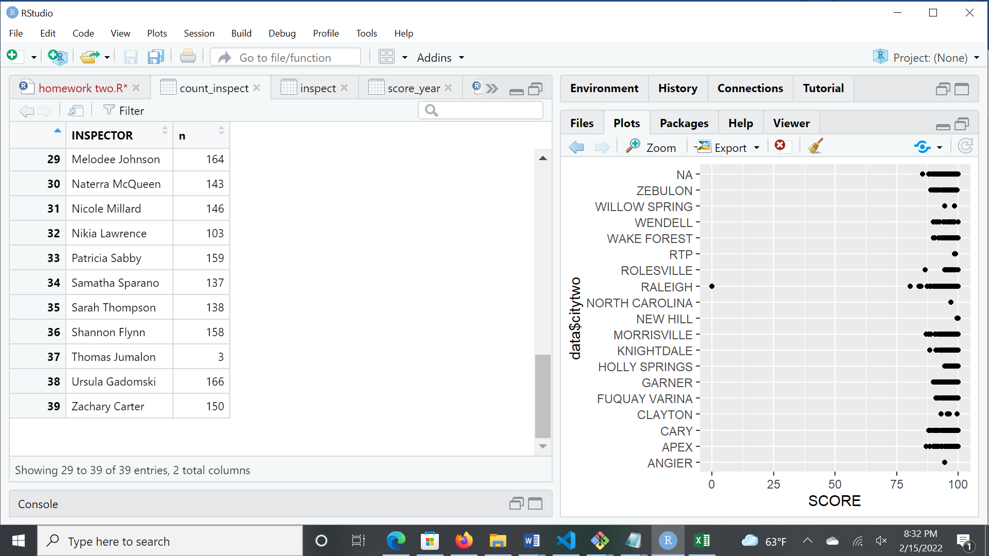 Sample size for inspectors

Yes, extreme results from the previous questions are due to small sample size.

6. The data file contains records for many types of food-service facility (e.g. restaurants,

food trucks, etc.). Are the scores for restaurants higher than other types of facility? [0.5

point]

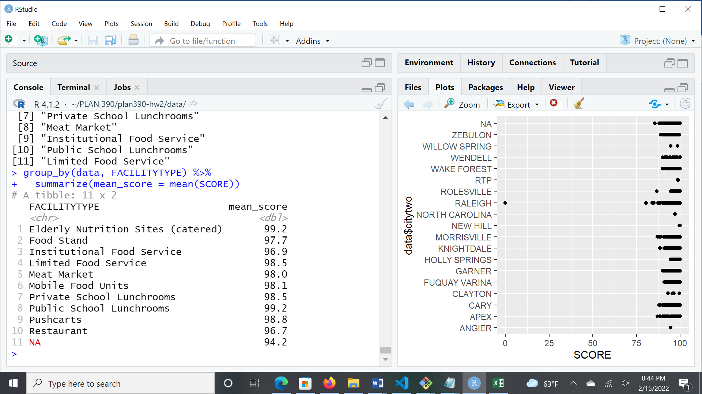

No, the scores for restaurants are lower than other types of facilities. Restaurants have the lowest mean score out of all the types of facilities.

7. Since restaurants are where the general public is most likely to interact with the food-

service system, Wake County Public Health is particularly interested in sanitation in

restaurants. Repeat the analyses above (1-5) for restaurants specifically. [2 points]

1. 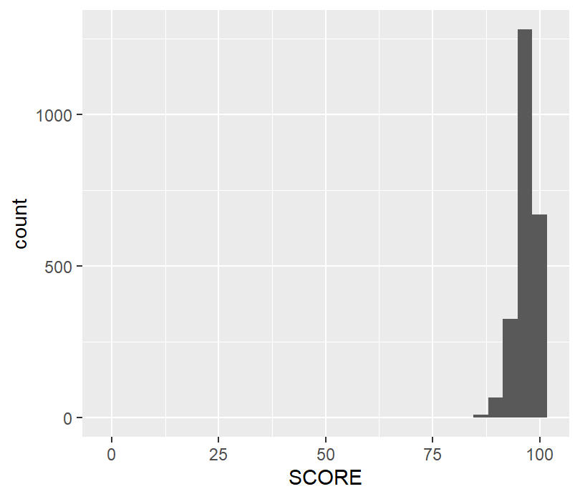
2. 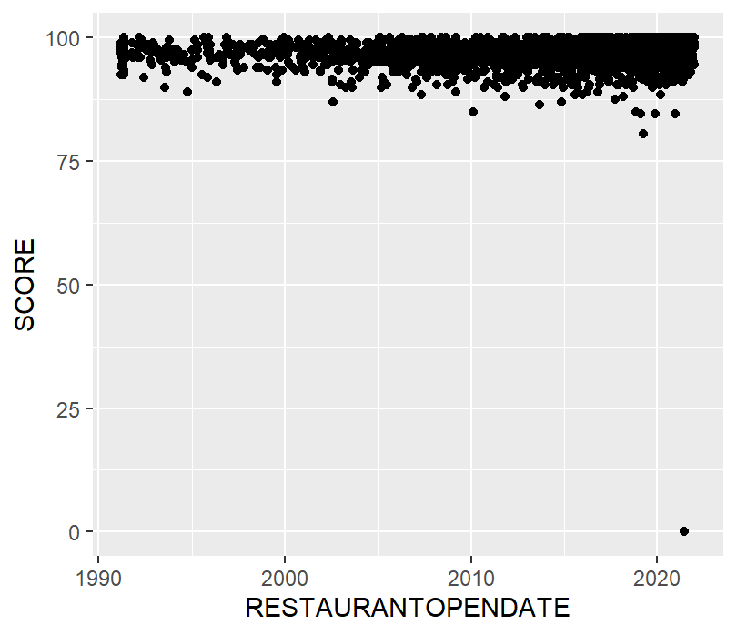

The older restaurants seem to score slightly higher than the newer restaurants.

1. 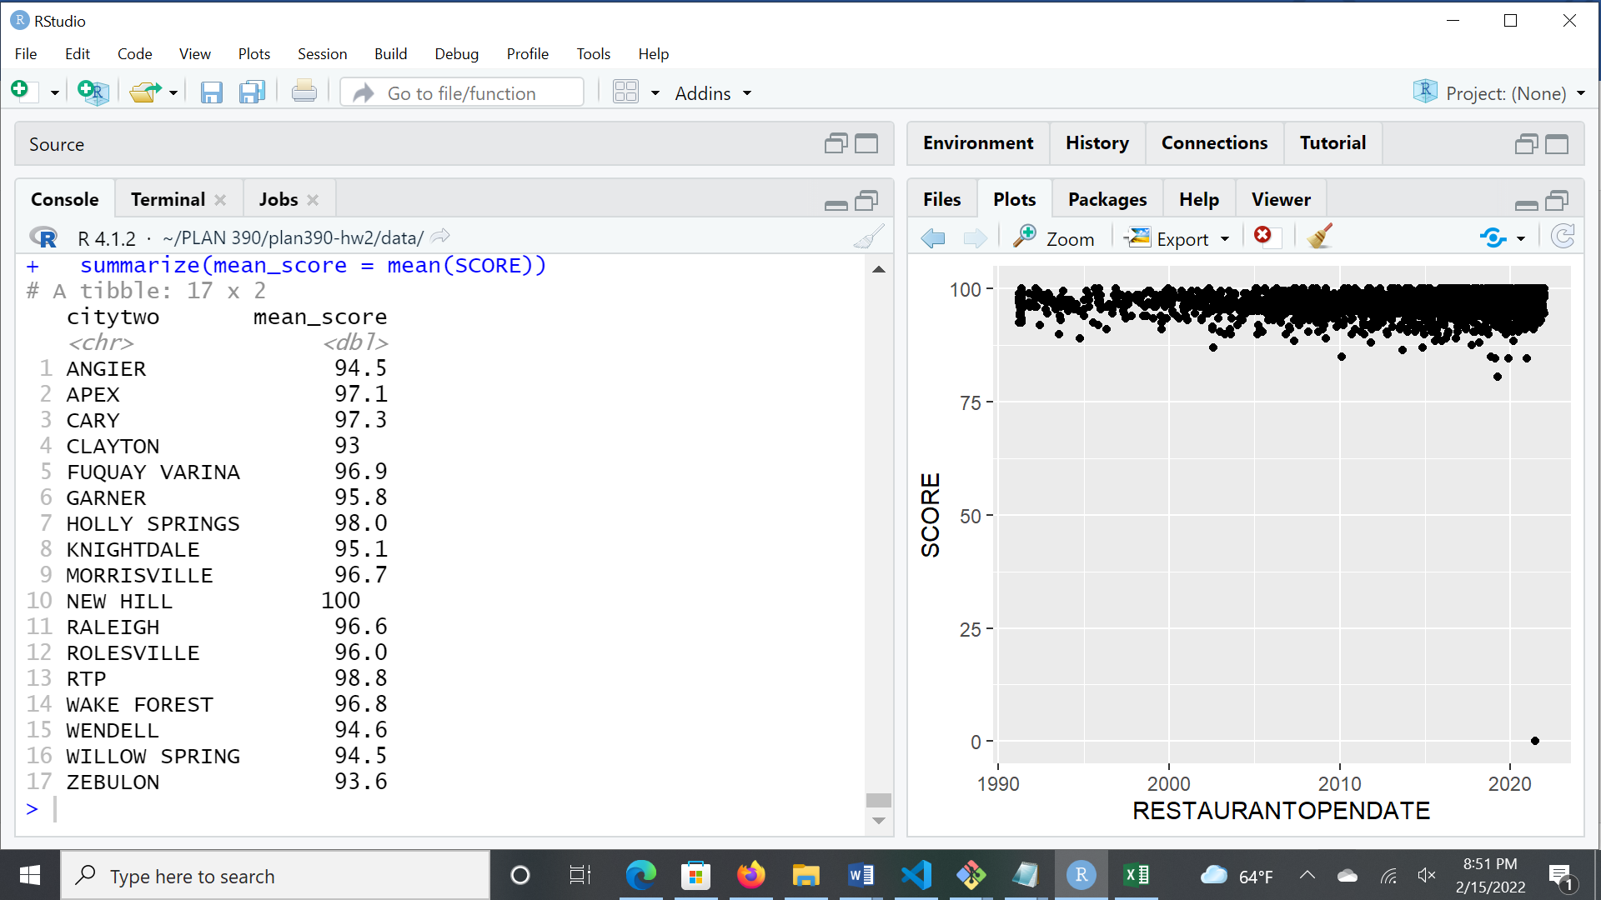

Yes, the inspection scores vary by city.

1. 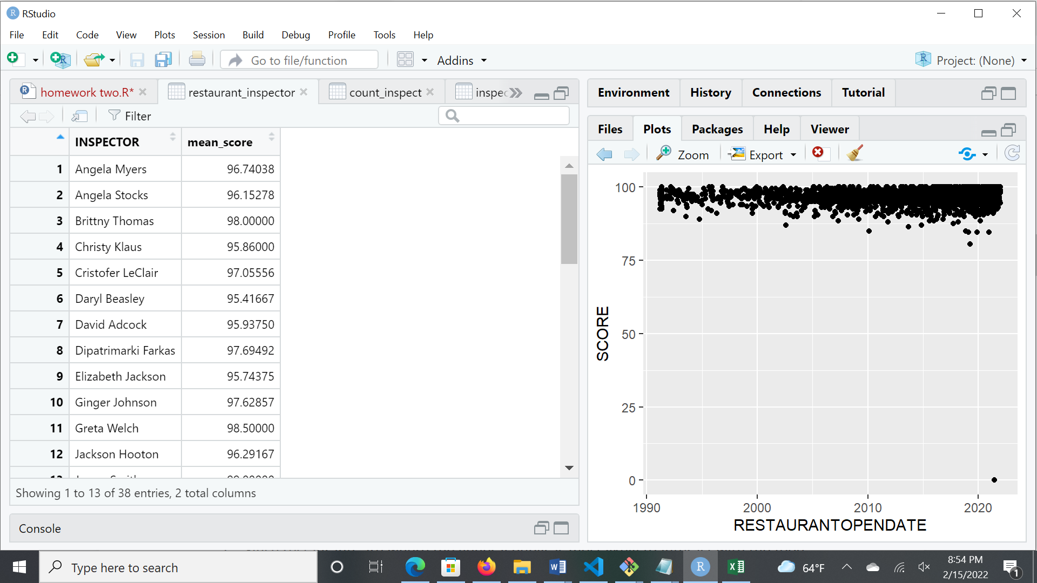 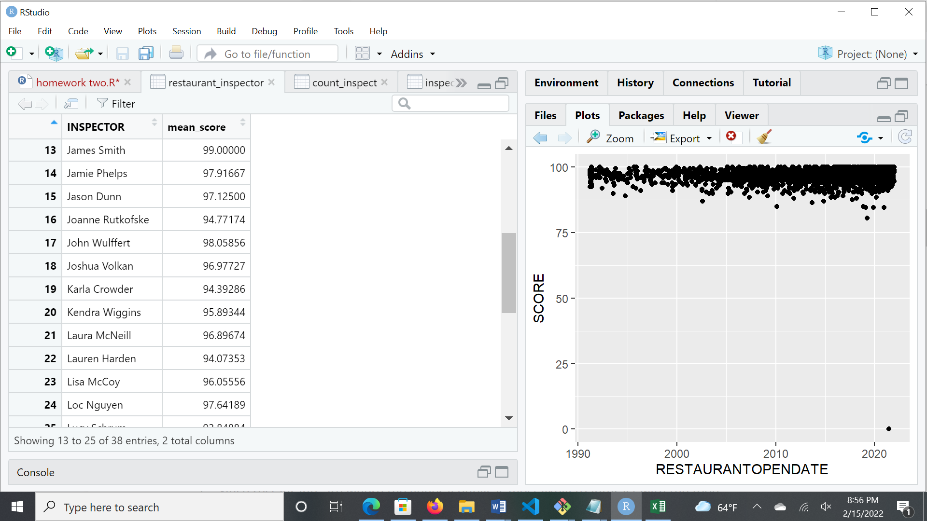 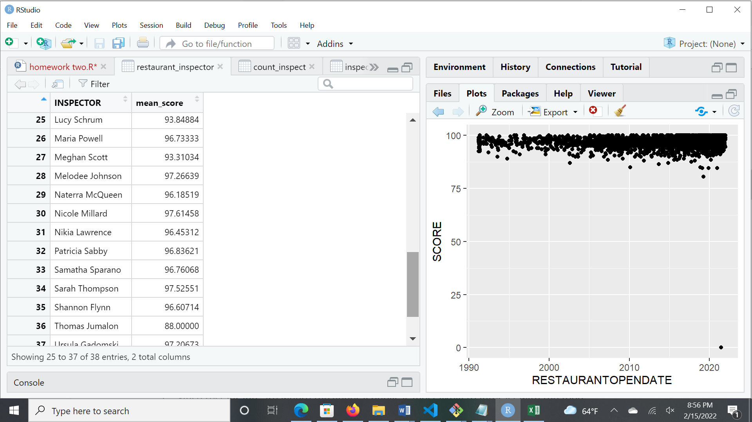 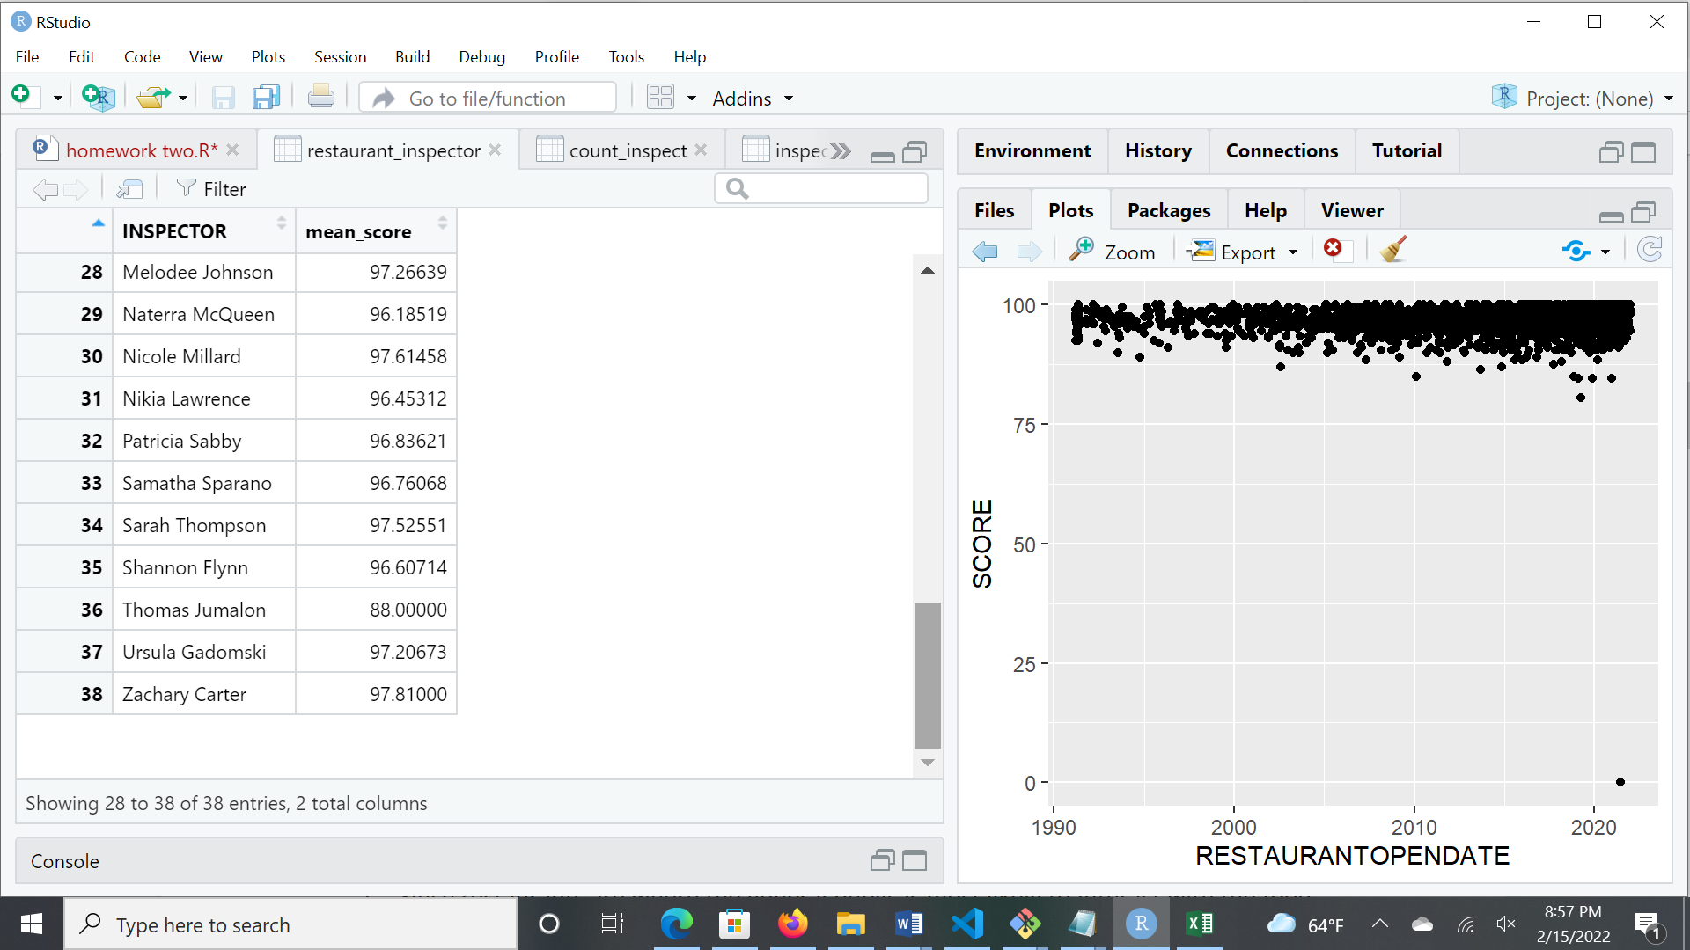

Yes, the inspection scores vary by inspector.

1. 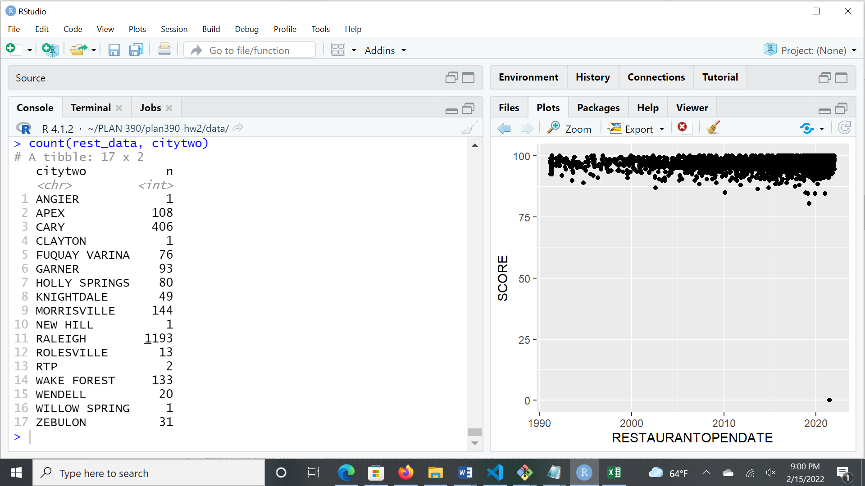 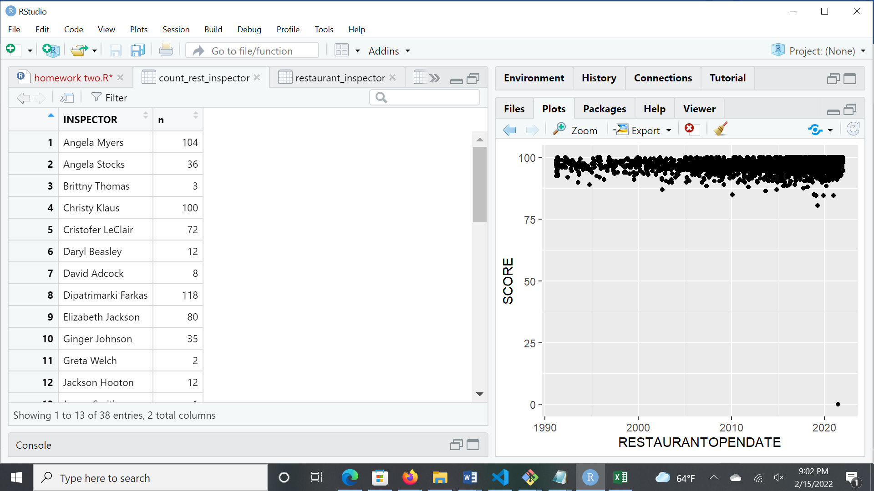 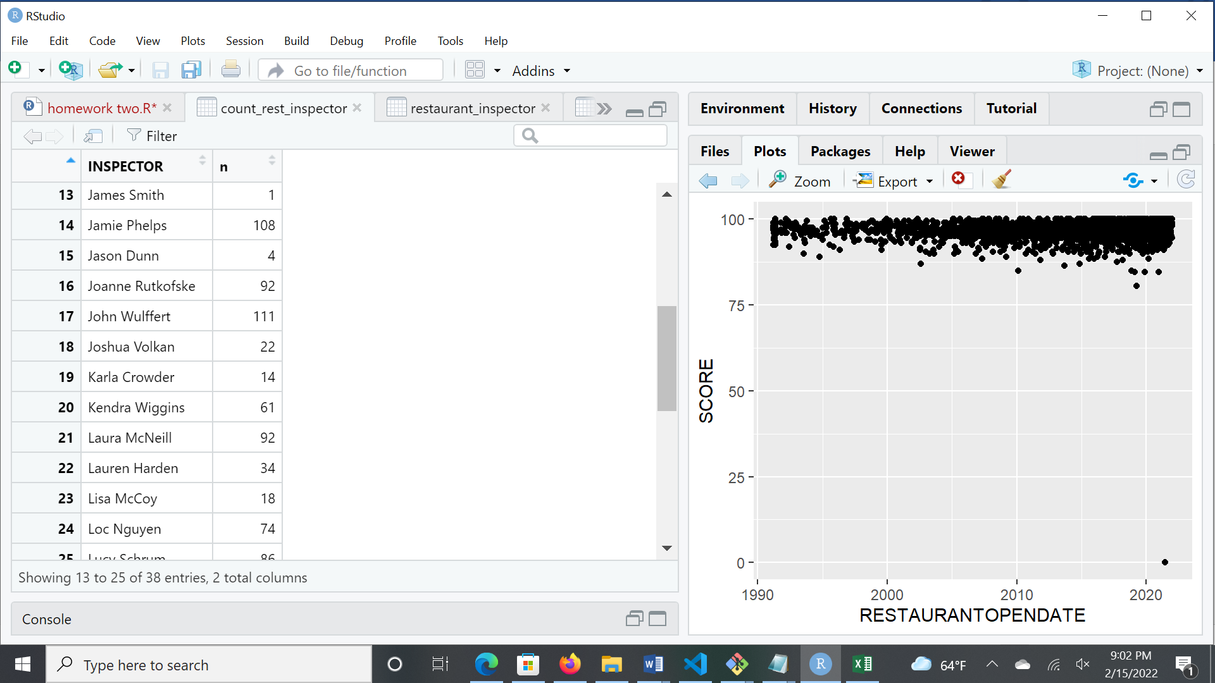 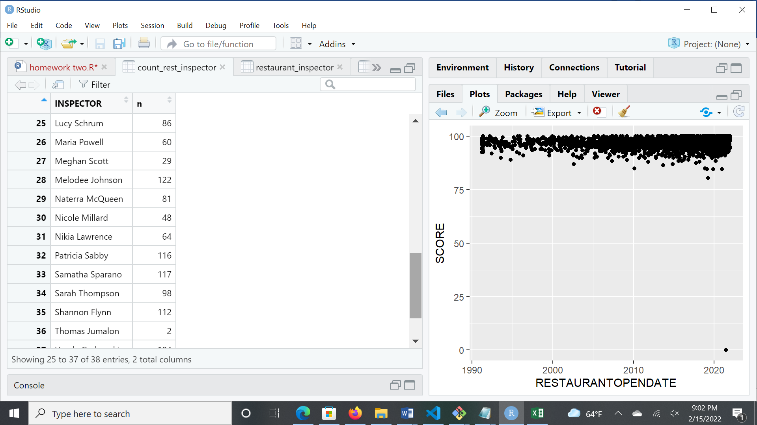 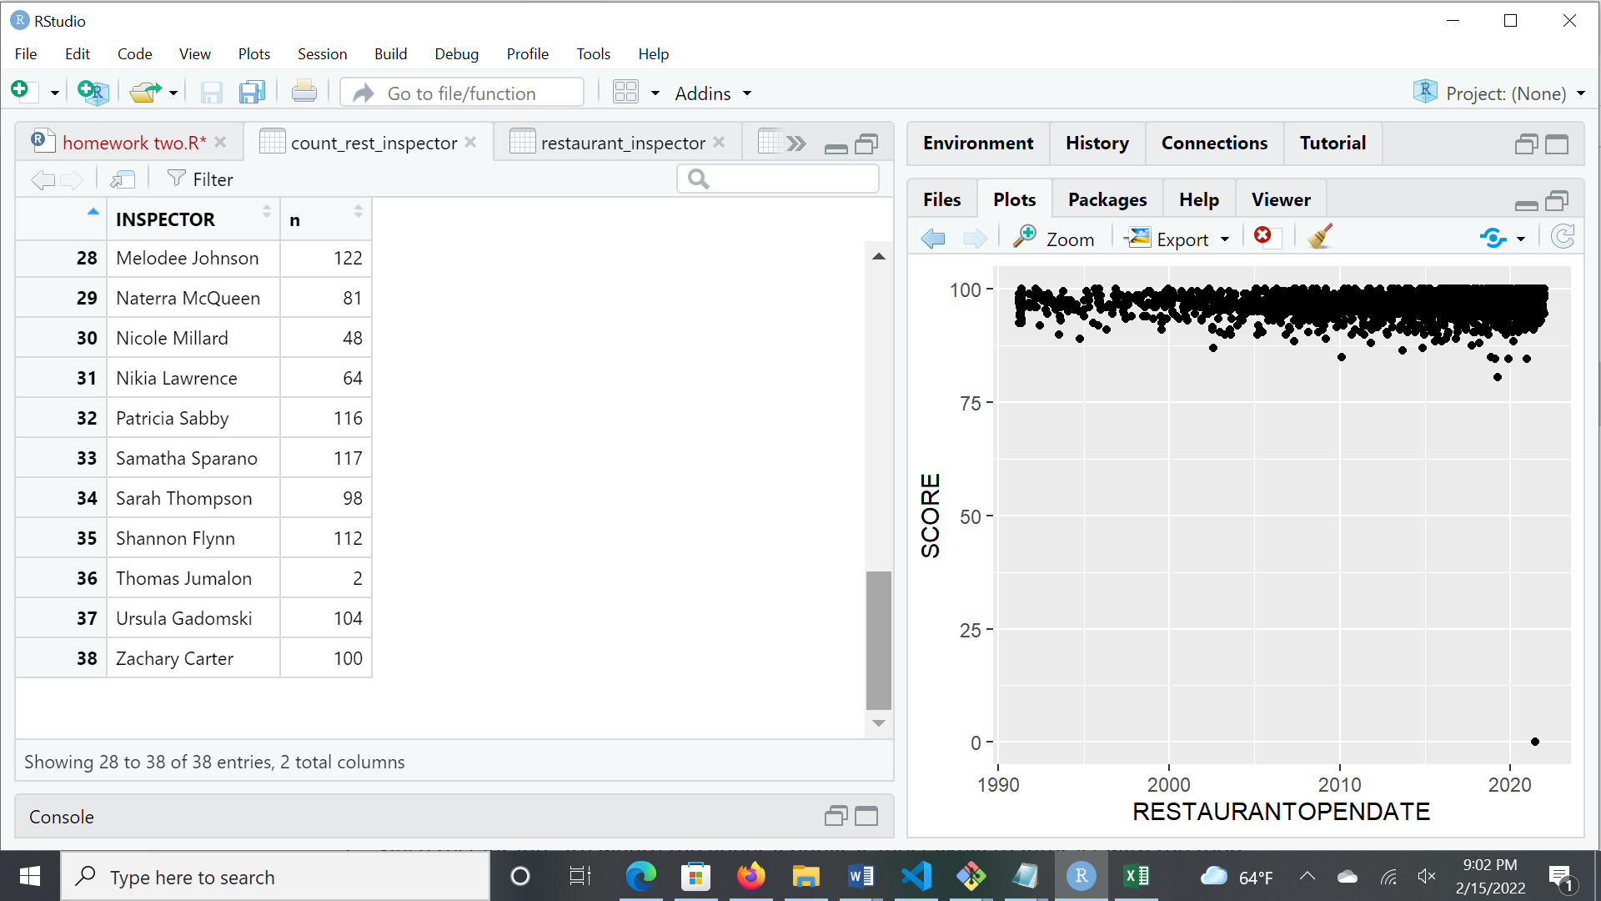

Yes, extreme results from the previous questions are due to small sample size.